Name – Kamal Agrahari TE IT A | Batch - B

ID – VU4F2223028 Sub – IP Lab

Experiment - 4 A

<!DOCTYPE html>

<html lang="en">

<head>

<meta charset="UTF-8" />

<meta name="viewport" content="width=device-width, initial-scale=1.0" />

<title>Paragraph Style</title>

</head>

<body>

<p id="Paragraph">This paragraph wil be styled using Javascript</p>

<button onclick="styleParagraph()">Style Paragraph</button>

<script>

function styleParagraph() {

const paragraph = document.getElementById("Paragraph");

paragraph.style.backgroundColor = "red";

paragraph.style.fontWeight = "bold";

}

</script>

</body>

</html>

Output



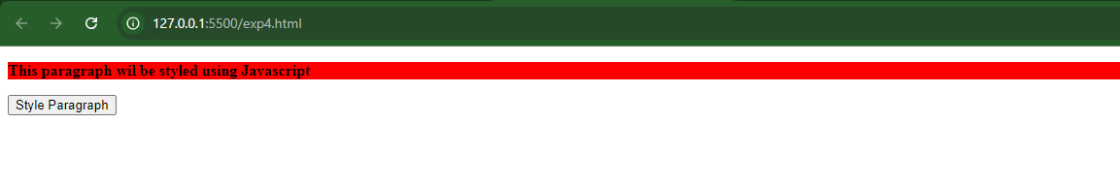

Experiment - 4 B

<!DOCTYPE html>

<html lang="en">

<head>

<meta charset="UTF-8" />

<meta name="viewport" content="width=device-width, initial-scale=1.0" />

<title>Class Person and Student</title>

</head>

<body>

<h1>Student Details</h1>

<div id="student1"></div>

<div id="student2"></div>

<div id="student3"></div>

<script>

class Person {

constructor(name, age) {

this.name = name;

this.age = age;

}

displayPersonInfo() {

return `Name: ${this.name}, Age: ${this.age}`;

}

}

class Student extends Person {

constructor(name, age, course, marks) {

super(name, age);

this.course = course;

this.marks = marks;

}

displayStudentInfo() {

return `${this.displayPersonInfo()}<br>Course: ${

this.course

}, Marks: ${this.marks}`;

}

}

const student1 = new Student("Anurag", 19, "BEIT", 95);

const student2 = new Student("Vivek", 20, "BEIT", 90);

const student3 = new Student("Amritya", 20, "BEIT", 60);

document.getElementById("student1").innerHTML =

"<h2>Student 1 Details:</h2>" + student1.displayStudentInfo();

document.getElementById("student2").innerHTML =

"<h2>Student 2 Details:</h2>" + student2.displayStudentInfo();

document.getElementById("student3").innerHTML =

"<h2>Student 3 Details:</h2>" + student3.displayStudentInfo();

</script>

</body>

</html>

Output

